What is Microservices?
Microservices is an architecture wherein all the components of the system are put into individual components, which can be built, deployed, and scaled individually.

Microservice Architecture

Scenario:
Alice is an avid user of mediamore. She uses mediamore regularly to watch her favorite series online. She recently missed watching an episode of her favorite TV show.
When Alice logs in to the application, she sees the most recommended content on her home page. After some searching, she finally finds her TV Show.
But, what if Alice wants to get her TV Show with a single click.
How will the developers work together to fulfill Alice’s request?
Alice’s request is passed on to the Identity Provider. Identity provider thus authenticates Alice’s request by identifying her as a regular user on mediamore.
These requests are passed to the API Gateway which acts as an entry point for Alice to forward her requests to the appropriate microservices.
Each feature has its own working microservice, handling their own data. These microservices also have their own load balancers and execution environments to function properly.
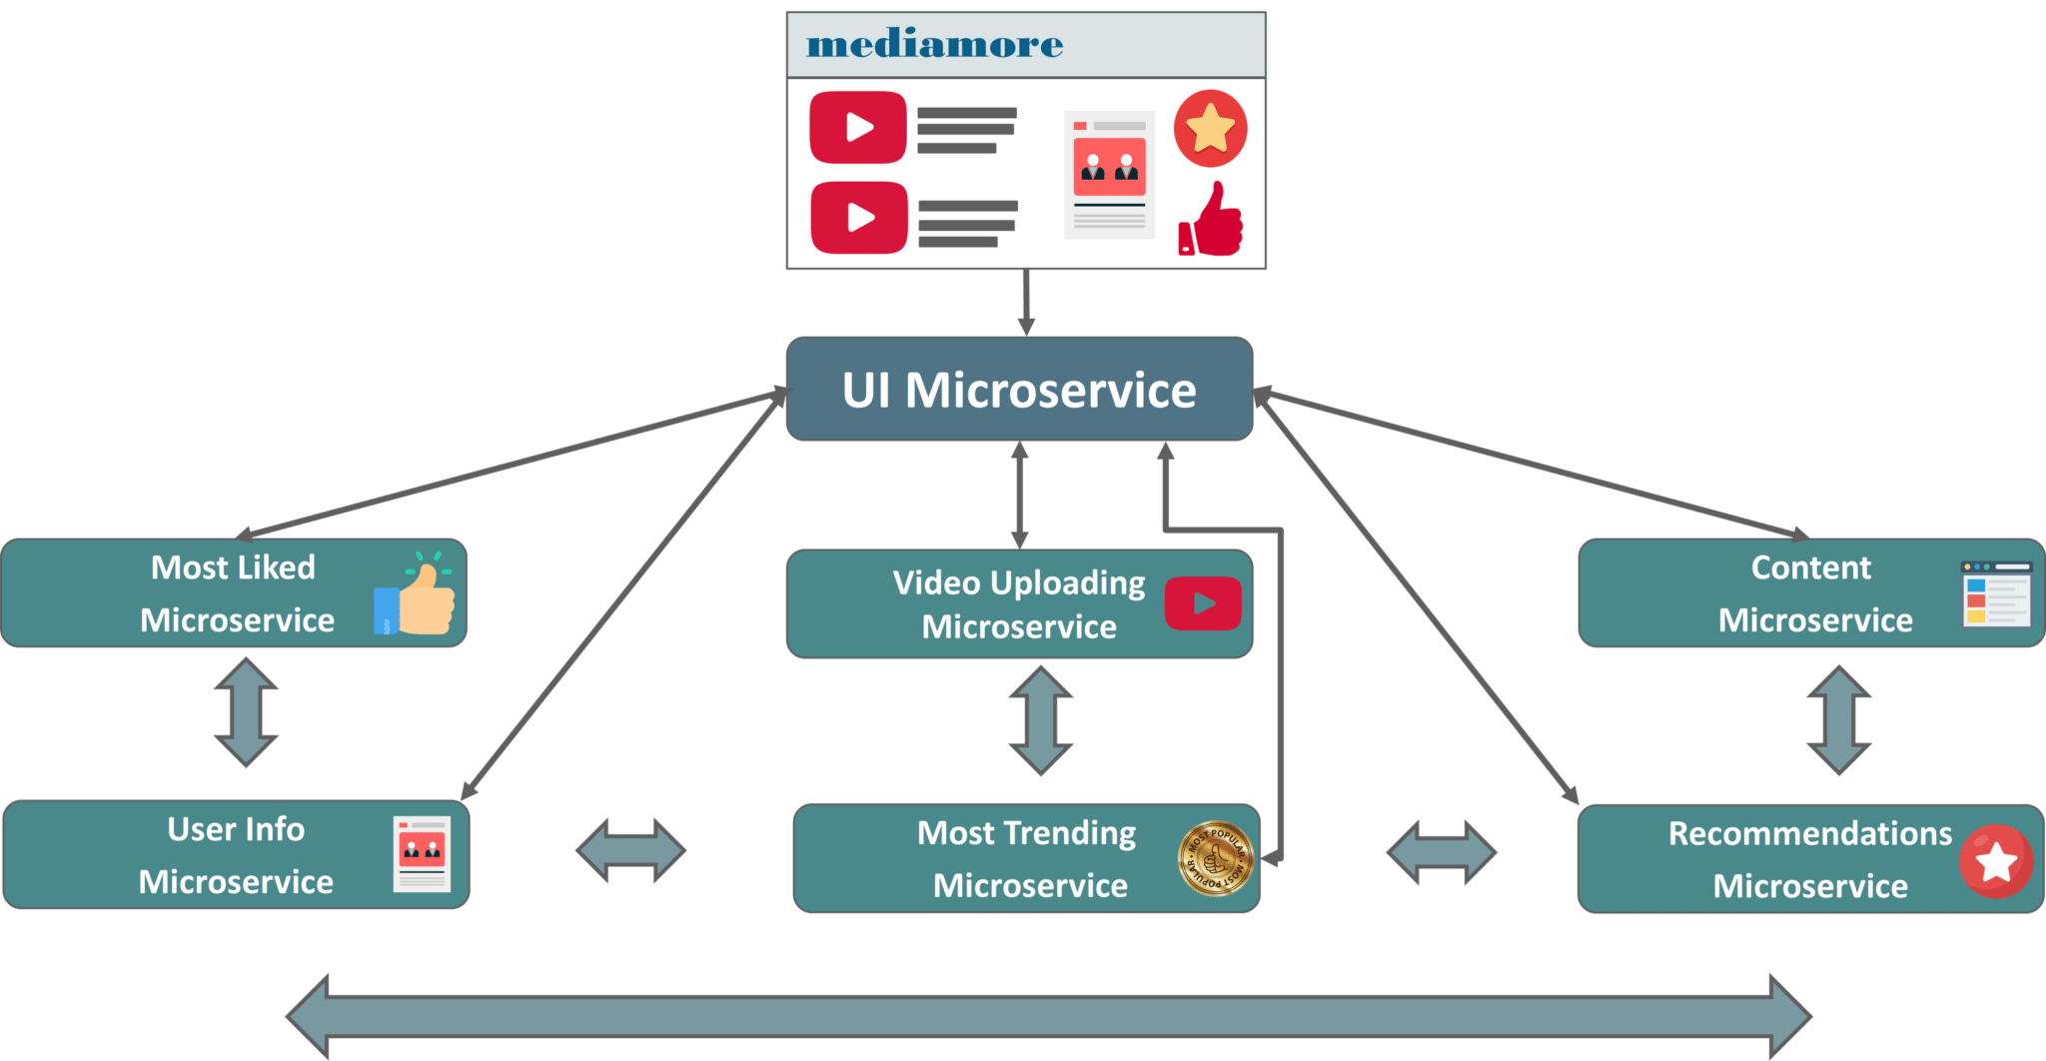

Refer to the diagram below. Each microservice is handled by a small agile team such as content team, video uploading team, most trending team, search team etc.

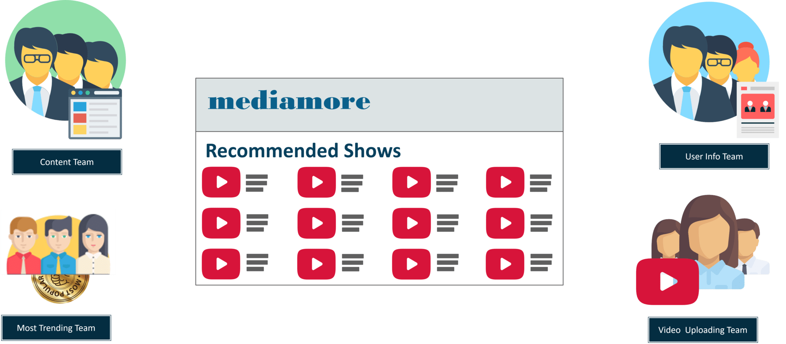

- The content team consists of millions of TV Shows that the application provides.
- The video uploading team have the responsibility to upload all the content into the application
- The most trending team houses the most trending shows according to the geographical location of users and so on.

These small teams of developers relate each and every piece of content with the metadata that describes the searched content. Then, metadata is fed into another microservice i.e. the search function which ensures Alice’s search results are captures into the content catalog.
Then, the third microservice i.e. most trending microservice captures the trending content among all the mediamore users according to their geographical locations.
The content from this microservice is what Alice sees when she first logs into mediamore.
These individually deployable microservices are put in specific containers to join the application. Containers are used to deliver the code to the sector where deployment is required.
But before they join the application to work together, they have to find each other to fulfil Alice’s request.
How do these microservices find each other?
Microservices use service discovery which acts as a guide to find the route of communication between each of them. Microservices then communicate with each other via a stateless server i.e. either by HTTP Request/Message Bus.
